**A picture containing clipart

Description generated with very high confidence**

CREATING AN INGRESS

DevOps Certification Training

[**support@intellipaat.com**](mailto:support@intellipaat.com)

**+91-7022374614**

**US: 1-800-216-8930(Toll Free)**

**CREATING AN INGRESS**

**Steps for Master**

**Step 1:** We will first have to install an ingress controller ‘nginx’. Execute the following command:

$ kubectl apply -f https://raw.githubusercontent.com/kubernetes/ingress-nginx/master/deploy/mandatory.yaml

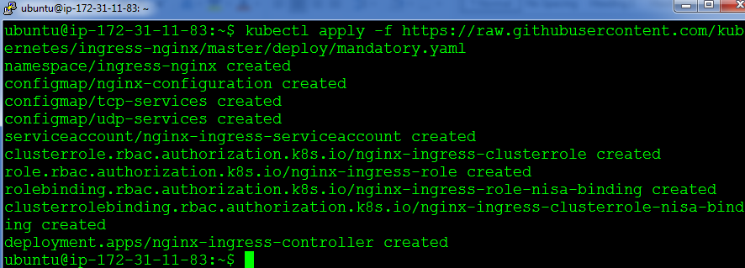

**Step 2:** Next install a service for this ingress controller, using this command:

kubectl apply -f https://raw.githubusercontent.com/kubernetes/ingress-nginx/master/deploy/provider/baremetal/service-nodeport.yaml

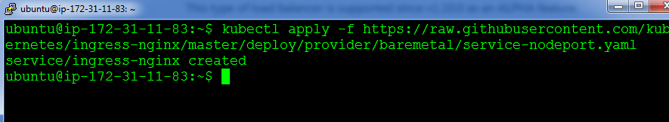

**Step 3:** Next, since ingress routes to only cluster-ip services, let us delete our previously created nginx nodeport service and create a service with clusterip for nginx. Use the following commands:

$ kubectl delete service nginx

$ kubectl create service clusterip nginx –tcp=80:80

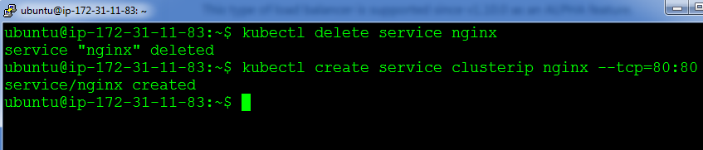

**Step 4:** Next, we will have to create an ingress rule, create an ingress.yaml file with the below code:

apiVersion: extensions/v1beta1

kind: Ingress

metadata:

name: simple-fanout-example

annotations:

nginx.ingress.kubernetes.io/rewrite-target: /

spec:

rules:

- http:

paths:

- path: /nginx

backend:

serviceName: nginx

servicePort: 80

**Step 5:** Finally, create the ingress rule using the following command:

$ kubectl create –f ingress.yaml

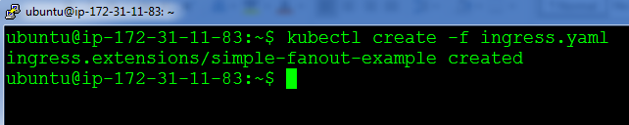

**Step 6:** Let’s verify if ingress is working or not, by checking the nodeport of the ingress service, for checking the nodeport use the following command:

$ kubectl get svc –n ingress-nginx

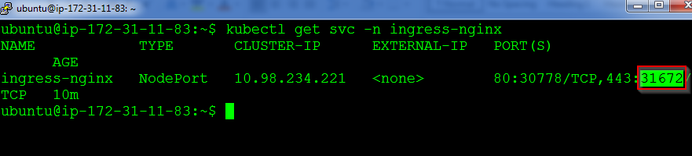

**Step 7:** Finally verify by browing to https://<IP-address-of-master or slave>:<nodeport>/nginx

